Lesson 2 Homework | LT 2.2 and 2.3 | 3-7, 9, 12 (Graph on worksheet) (FRONT PAGE)  3-8, 20, 21 (BACK PAGE)  ROTATION WS

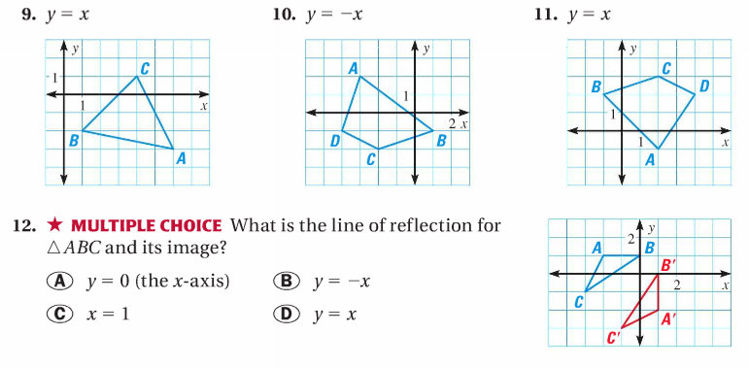
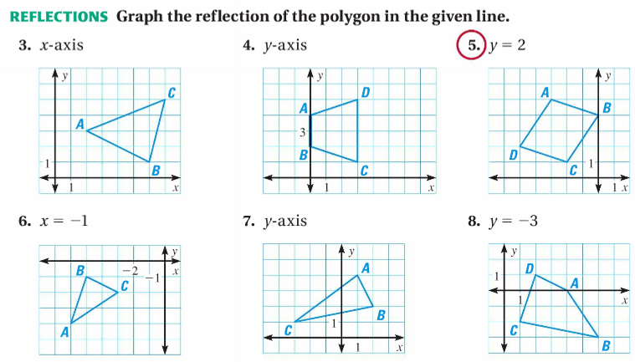

Lesson 2 Homework | LT 2.2 and 2.3 | 3-7, 9, 12 (Graph on worksheet) (FRONT PAGE)  3-8, 20, 21 (BACK PAGE)  ROTATION WS
